**TERM I TOPICS TO BE COVERED.**

1. Keeping poultry and bees

2. Measurements

3. Immunization

4. The digestive system

**WEEK ONE**

**THEME: SCIENCE IN HUMAN ACTIVITIES AND OCCUPATIONS.**

**TOPIC: KEEPING POULTRY AND BEES.**

**Lesson 1**

**POULTRY KEEPING**

**New words:**

* **Poultry keeping** is the rearing of domestic birds.
* **Poultry** are domestic birds.
* **Fowls** are domesticated birds.

**Types of poultry**

-Chicken

-Ducks

-Turkeys

**Domesticated birds:**

-Pigeons

-Guinea fowls

**Reasons why farmers keep poultry**

-For egg production

-For meat (Chicken) production

**Other uses of poultry to people:**

-To get feathers for different purposes e.g. making pillows, decoration, dancing props, cushions.

-Some birds are kept as pets in homes e.g. peacocks, hens, parrots.

-Source of farm yard manure from the droppings.

**Exercise:**

1. List down any two examples of poultry.
2. State the difference between poultry and poultry keeping.
3. Why do farmers keep poultry?
4. How is poultry keeping useful to crop farmers?

**Activity:** Observing types of poultry

………………………………………………………………………………………

**Lesson 2**

**New words:**

* **Incubation:** this is the period which birds’ eggs take to hatch.
* **Preening:** this is the act of birds cleaning and arranging their feathers.
* **Spur**

**EXTERNAL PARTS OF A BIRD**

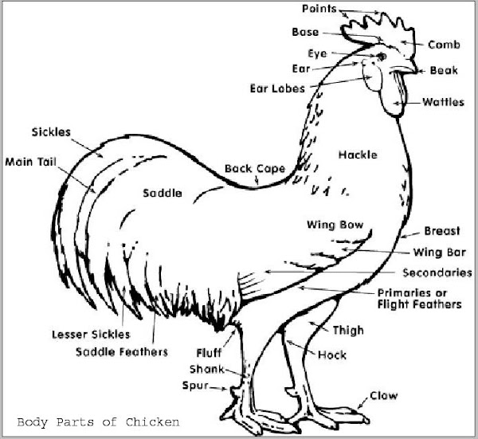

**Importance of each part on a bird**

**Spur -** For protection / defence

**Beak / bill -**For picking food

-For defence

-For building their nests

-To clean itself and arrange its feather (preening)

**Toe nails (claws) -**To scratch the ground when looking for food.

-For defence.

**Comb and wattle -**For attracting mates.

-They keep poultry cool in hot weather.

**Feathers -**To protect the delicate skin

-To keep the birds warm

-For incubation of eggs.

-For brooding their young ones.

**Note: -**Feathers are also used for identification

-For courtship (attracting of opposite sex for mating) incase of a cock.

**Most important internal parts of a bird:**

**Crop:** it moistens food.

**Gizzard:** it stores grit.

**Grit:** crushes food.

**Exercise:**

1. How is a beak useful to a bird?
2. Give any two uses of feathers to birds.
3. How is a spur useful to a cock?

**Activity:** Drawing a diagram showing a cock.

**……………………………………………………………………………………**

**Lesson 3**

**New words:**

* **Feathers:** these are structures found on the body of a bird**.**
* **Breed:** is a group of animals with special characteristics.
* **Breeding:** is the continuous mating of animals to get a desired breed.

**Types of feathers: -**Quill feathers

-Covert feathers

-Down feathers

-Filoplume feathers

**Differences between a hen and a cock**

|  |  |
| --- | --- |
| **A cock** | **A Hen** |
| 1. Has a large spur 2. Has a large comb and wattle 3. Does not lay eggs 4. Has large ear lobes | Has a small spur  Has a small comb and wattle  Lays eggs  Has small ear lobes |

**NB:** Observe the real bird (cock and hen)

**BREEDS OF CHICKEN**

**Types of breeds of chicken kept in Uganda**

1. Local breeds (Indigenous)
2. Exotic breeds
3. Cross breeds

**Local breeds**

**Characteristics of local breeds of chicken**

1. They lay few eggs.
2. Local breeds are resistant to diseases.
3. Local breeds look for their own food.
4. Local breeds incubate their own eggs.
5. They brood their own chicks.
6. They produce little meat.
7. They grow slowly.

**Exotic breeds**

**Characteristics of exotic breeds of chicken.**

1. They grow faster.
2. They are less resistant to disease.
3. They lay many eggs.
4. They produce a lot of meat.

**Examples of exotic breeds of chicken:**

1. Rhode Island Red. 5. Minorca.
2. New Hampshire. 6. Light Sussex
3. Orpington 7. White leghorn
4. Ancona 8. Sykes

**NB:** Exotic breeds can either be grouped as heavy breeds or light breeds.

**Exercise:**

1. State one difference between a hen and a cock.
2. Name the two groups of breeds of poultry kept in Uganda.
3. Mention any two advantages of keeping local breeds of chicken.

**Activity:** Observing the features of local breeds of poultry.

**…………………………………………………………………………………………………**

**Lesson 4**

**New words:**

* **Cross breeding:** the mating of local breeds with exotic breeds of animals.
* **Hybrid**
* **Mating**

**How to improve upon the local breeds of chicken**

1. Through cross breeding of local breeds with exotic breeds.
2. Through selective breeding (choosing breeds of good quality).

**Advantages of cross breeding**

1. Encourages fast growth in birds
2. Results into more eggs being laid by the offspring.
3. Improves on the productivity of poultry.

**Advantages of keeping Exotic breeds of chicken**

1. Exotic breeds grow very fast.
2. Exotic breeds lay many eggs.

**Disadvantages of exotic breeds of chicken**

1. Exotic breeds are not resistant to diseases.
2. They do not incubate their eggs.
3. They cannot look for their own food.
4. Exotic breeds are expensive and difficult to look after.
5. They cannot brood their own chicks.

**Compare the local poultry with exotic breeds.**

|  |  |
| --- | --- |
| **Local poultry** | **Exotic breeds of poultry** |
| * More resistant to diseases | * Less resistant to diseases |
| * Produce few eggs | * Produces many eggs |
| * Small in size | * They are big in size |

**Exercise:**

1. How do farmers improve on their local breeds of poultry?
2. Give any two advantages of cross breeding.
3. Write any two disadvantages of exotic breeds of chicken.

**Activity:** Observing the local and exotic breeds of chicken.

**……………………………………………………………………………………………**

**Lesson 5**

**New words:**

* **Mash:** chicken feeds.
* **Trough:** a container with open surface which can hold water.

**Types of chicken**

There are three main types of chicken kept in Uganda.

**Layers:** Kept for egg production

**Broilers:** Kept for meat production

**Dual Purpose:** Kept for both meat and eggs production.

**Feeding of poultry:**

|  |  |  |  |
| --- | --- | --- | --- |
| **Type of chicken** | **Feed** | **Rich in** | **Age** |
| 1. Chicks 2. Growers 3. Broilers 4. Layers | Chick mash  Growers’ mash  Broilers’ mash  Layers’ mash | proteins  proteins  proteins  calcium | 0 – 4 weeks  4 – 16 weeks  4 – 8 weeks  Over 16 weeks |

**Composition of chicken mash**

1. Silver fish
2. Bone meal
3. Common salts
4. Maize meal
5. Sea shells (rich in calcium for the strong growth of bones)

**Feeding and drinking equipment:**

**Feeding trough Drinker**

Where feeds are put for birds to eat. Where water is put

**Exercise:**

1. Give any two types of chicken kept in Uganda.
2. Name any two types of chicken feeds.
3. Why are chicks feed on chick mash?

**Activity:** Observing feeding and drinking troughs

Putting feeds and water in the troughs.

**…………………………………………………………………………………………**

**Lesson 6**

**New words:**

* **Brooding:** special cares given to chicks bellow 8 weeks**.**
* **Brooder:** a special structure for raising chicks bellow 8 weeks.

**BROODING**

Brooding is giving special care and attention to chicks below 8 weeks.

**Types of brooding**

There are mainly two types of brooding namely;

1. Natural brooding
2. Artificial brooding

**Natural brooding:** Is where the brooding hen cares for her chicks.

It provides the chicks with security, warmth and food.

**Advantages of natural brooding**

1. The broody hen provides the chicks with food other than the farmer.
2. It saves the farmer from expenses of buying an artificial brooder.
3. Natural brooding is cheap to the farmer.

**Disadvantages of natural brooding**

1. Chicks can easily die if poorly protected.
2. Chicks can easily be killed by wild animals like kites, eagles, wild cats, monitor lizards etc.

**Artificial brooding:** Is where the chicks are kept in a brooder.

**BROODER**

A brooder is a special structure where farmers keep their chicks below 8 weeks.

**Types of brooders**

There are various types of brooders namely:-

**1**. **Infra-red lamp brooder:** Is where the infra-red lamp provides heat and light energy.

Feeding and drinking troughs are kept inside the brooder.

Litter is put on the floor to make chicks warm and more comfortable.

**2. Kerosene (paraffin) brooder:**

In this system a kerosene lamp is used to provide warmth and light. This lamp is put on a raised ground and on the floor or lamp above the chicks.

**3. Charcoal brooder:**

In this system a charcoal stove is used to provide (warmth / heat) and light.

**Other examples of artificial brooder are:**

* Hot water pipe brooder
* Gas brooder

**Exercise:**

1. What is brooding as used in poultry?
2. Give any one example of a brooder.
3. Why would a farmer prefer natural brooding to artificial brooding?

**Activity:** Visiting a poultry farm.

**……………………………………………………………………………………................**

**Lesson 7**

**Incubation**

**New words:**

* **Incubation**: is a process by which fertilized eggs are given favorable conditions in order to hatch into chicks.
* **Fertilization**: the union of male and female cells to form a zygote.

**Favorable conditions for eggs to hatch**

1. Good temperature (warmth) 320C - 380 C
2. Relative humidity (moisture) of 0%
3. Good ventilation (free circulation of air).

**Why some fertilized eggs fail to hatch even in the presence of favorable conditions:**

1. If an egg has double yolks
2. In case an egg has an abnormal shape
3. In case an egg is too small in size.
4. When an egg has no air space.
5. If an egg has a soft egg shell.
6. When the egg shell is cracked.

**Incubation period:**

Incubation period is the time taken by the eggs to hatch into chicks.

**Incubation period of the following birds**

|  |  |
| --- | --- |
| **Birds** | **Incubation period** |
| Hens | 21 days |
| Ducks | 28 days |
| Turkeys | 28 days |
| Geese | 30 days |
| Pigeons | 14 days |

**Exercise:**

1. What is incubation?
2. Why does an egg fail to hatch given all favorable conditions?
3. How long does a duck take to hatch its eggs?

**Activity:** Observing the eggs of a hen, turkey and a duck.

Drawing parts of an egg.

**………………………………………………………………………………………………**

**LESSON 8**

**Parts of an egg.**

**NEW WORDS:**

* **Chalaza:** a tissue in an egg which holds the yolk in position.
* **Albumen:** a tissue in an egg which provides food and water to the embryo.

**Diagram showing parts of an egg:**

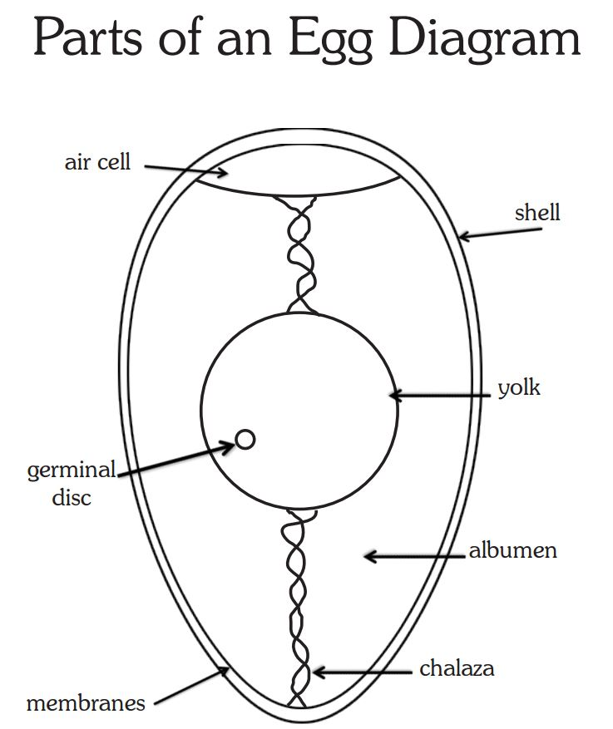

**Functions of each part**

**Egg shell:** It protects the inner egg content.

It is made of mineral salt called calcium

**Chalaza:** It balances the yolk in position to get equal temperature during incubation period.

**Yolk:** It supplies food and mineral salts to the growing chick.

We obtain proteins from the yolk.

**Albumen:** It supplies water and other food values to the growing chick.

It allows oxygen from the air space to pass through to the growing chick and carbon dioxide from the growing chick to diffuse to air space.

**Air space:** Keeps air in an egg.

**Exercise:**

1. How is the egg shell important in an egg?
2. Give the role of the air space in an egg?
3. What food value is got from eating eggs?

**Activity:** Unshelling boiled and unboiled eggs and observing the parts.

**………………………………………………………………………………………………**

**Lesson 9**

**New words:**

* **Incubation:** the period a birds eggs take to hatch.
* **Incubator:** a machine which provides all conditions for eggs to hatch.

**Types of incubation**

1. Natural incubation
2. Artificial incubation

**Natural incubation:**

In natural incubation the broody hen provides all the necessary conditions as it sits on the eggs for 21 days.

A broody hen can incubate between 15 – 20 eggs at once.

**Advantages of natural incubation**

1. Little or no attention is paid to an incubating hen.
2. Chicks get care from the mother hen.
3. It is cheap and easy to manage by the poultry farmer.
4. Does not require brooding of chicks.

**Disadvantages of natural incubation**

1. Few chicks can be hatched at once.
2. The hen may get diseases and parasites at an early stage.
3. The hen may not be good at incubation.
4. Natural brooding is not very effective for commercial production.

**Artificial incubation:**

Artificial incubation is the type of incubation where the eggs are put inside an incubator to hatch into chicks.

NB: In an incubator the conditions for hatching like temperature, humidity are maintained at good level at all times.

**Advantages of artificial incubation**

1. Man eggs can be hatched at once.
2. It can be used for commercial purposes.
3. It does not require the presence of broody hen.
4. Diseases can be easily controlled.

**Disadvantages of artificial incubation**

1. Artificial incubation is expensive
2. It requires constant supervision
3. It needs expert or skilled attention and care.

**Exercise:**

1. Name the two types of incubation.
2. State any two advantages of artificial incubation.
3. Give any two disadvantages of natural incubation

**Activity:** Preparing nests for birds to lay their eggs.

**………………………………………………………………………………………………**

**Lesson 10**

**Systems of keeping poultry**

**New words:**

* **Litter in poultry:** material placed on the floor of a poultry house.
* **Fold:** a special shelter for few birds.

There are four systems of keeping poultry

1. Free range system (open system)
2. Deep litter system
3. The cage (battery) system
4. The art / fold / pen system

**Free range system**

Free range system is where birds are allowed to move (roam) about to look for food but shelter is provided to them.

**Advantages of free range system**

1. Birds eat a variety of foods
2. Birds look for their own food
3. Free range system is cheap to maintain
4. It reduces labour to the farmer.

**Disadvantages of free range system**

1. Birds can easily get lost
2. The eggs can easily get lost and are difficult to collect.
3. The birds can easily be eaten by wild animals like kites, eagles cats etc.
4. Eggs become dirty easily
5. It is difficult to control diseases and parasites.

**Fold / Ark / pen system**

Is where a limited number of birds are kept in a small moveable house called a fold / pen /ark.

1. Birds lay their eggs in the pens / folds/ arks.
2. These folds are moved from one place to another every day (daily)
3. The fold is made of wood, wire mesh and sticks tied together.

**Structure of a pen**

[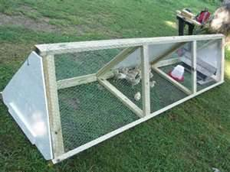](http://i281.photobucket.com/albums/kk217/patandkaren/chicken_pen.jpg)

**Exercise:**

1. List down any two systems in poultry keeping.
2. Give any one advantage of free range system.
3. Write any two disadvantages of free range system.

**Activity:** Collecting materials used in making of poultry houses like pens.

**………………………………………………………………………………………………**

**WEEK 2**

**Lesson 1**

**New words:**

* **Litter in poultry:** material placed on the floor of a poultry house.
* **Fold:** a special shelter for few birds.

**Advantages of the pen system**

1. It is cheap to maintain compared to cage system or deep litter system.
2. Manure is evenly distributed on the farm.
3. Birds are restricted in movement
4. Birds can easily get vitamins and sunlight.

**Disadvantages of the pen system**

1. It is more expensive than free range system
2. The folds easily get old and break due to constant movements from one place to another.
3. Birds are easily bored since their movement is restricted to their fold / pen.
4. More land is needed to shift the folds.
5. Much labour is needed to move the folds daily.

**Deep litter system**

Is a system where the birds are kept in a house through out.

1. The feeds and water are given to the birds inside the house.
2. Litter is put on the floor to keep the birds warm among others.
3. The house is well lit to allow the birds to feed constantly.

**Advantages of the deep litter system**

1. The litter poured on the floor can be used as manure.
2. Birds are protected from thieves and wild animals e.g. wild cats.
3. Many birds can be kept in a small house.
4. Clean eggs are collected.
5. This system can be used for all stages of birds.
6. Birds cannot get lost as their movement is controlled.

**Disadvantages of deep litter system**

1. It encourages vices e.g. egg eating, cannibalism, toe pecking etc.
2. Litter can be a fire hazard (can easily catch fire).
3. It is more expensive than free range system.
4. The litter cans hide (keep) pests and parasites.

**Exercise:**

1. Write any one disadvantage of pen system.
2. Give any two advantages of deep litter.

**Activity:** Observing litter e.g. coffee husks, wood shavings, rice husks etc.

**…………………………………………………………………………………………………**

**Lesson 2**

**New words:**

* **Cage:** special small rooms meant for raising one or two birds.
* **Droppings:** wastes released by birds as faeces.

**Components of litter (what litter is made of)**

Coffee husks, wood shavings, rice husks, crushed maize cobs and saw dust.

**Importance of litter in a poultry house.**

1. Prevent the eggs from breaking as they are laid.
2. Litter got from the house can be used as manure by crop farmers.
3. Absorbs the water content from the droppings.

**Disadvantages of litter**

1. Litter hides parasites
2. Litter is a fire hazard.

**Battery (cage) system**

In this system, birds are kept in separate cages.

1. It is not commonly used in Uganda.
2. Each cage has one or two birds put outside the cages.
3. This enables people to feed the birds easily and reduce contamination of feeds by the birds themselves.
4. Cages can also be constructed in rows / one above the other.
5. The cage should have good ventilation.

**A diagram showing a cage**

[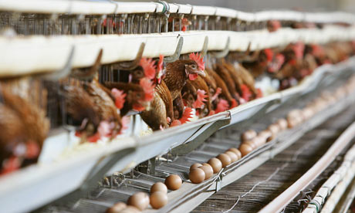](http://static.guim.co.uk/sys-images/Admin/BkFill/Default_image_group/2011/8/31/1314809207695/battery-hens-in-a-chicken-007.jpg)

**Advantages of battery system**

1. Diseases and diseased birds are easy to identify
2. It is easy to identify a bird that does not lay eggs.
3. Birds are very easy to control.
4. They are protected from thieves and wild animals.
5. Farmers can get manure easily.
6. There are less poultry vices than in the deep litter system.

**Disadvantages of battery system**

1. A lot of money is needed to start (so it is very expensive)
2. Birds do not eat whenever they need to.
3. Birds need much attention.

**Exercise:**

1. How is litter important in poultry keeping?
2. Give any disadvantage of litter in a poultry farm.
3. State any one advantage of battery system.

**Activity:** Collecting litter e.g. coffee husks, wood shavings, rice husks etc.

**………………………………………………………………………………………………….**

**Lesson 3&4**

**New words:**

* **Isolating:** separating the sick, aggressive or less productive animals from the good ones.
* **Disinfecting:** spraying animal homes to kill ecto-parasites.

**Poultry diseases**

1. Coccidiosis
2. Newcastle disease
3. Fowl typhoid
4. Fowl pox
5. Gumboro diseases
6. Avian leucosis
7. Salmonellosis
8. Worms

|  |  |  |  |  |
| --- | --- | --- | --- | --- |
| **Disease** | **Cause** | **Signs** | **symptoms** | **control** |
| Coccidiosis | protozoa | -Yellowish white diarrhea  -ruffled feathers  -drooping of feathers. | -loss of appetite.  -body weakness.  -dullness. | -isolating sick birds.  -kill sick birds  -keep feeding troughs clean. |
| Newcastle | Virus | -lameness  -sudden death  -staggering | -difficulty in breathing | -disinfecting poultry houses.  -vaccination  -Kill infected birds. |
| Fowl pox | Virus | -nasal and eye discharge  -reduced egg production | -difficulty in breathing | -disinfecting poultry houses.  -vaccination  Kill infected birds.  -hygiene in the poultry house. |
| Fowl typhoid | Bacteria | -watery greenish yellow droppings.  -folding the head close to the head. | -body weakness.  -loss of appetite | -vaccination  -Kill and burn infected birds. |
| Gumboro | Virus | -blood stained droppings  -ruffled feathers. | -body weakness.  -loss of appetite | -culling.  -vaccination.  -burning and burring infected animals. |

**Exercise:**

1. Mention any one poultry disease.
2. Identify one sign of coccidiosis.
3. How do farmers control the spread of newcastle disease?

**Activity:** Cleaning feeding troughs.

Disinfecting poultry houses.

**…………………………………………………………………………………………………**

**Lesson 5**

**New words:**

* **Parasites**: living organisms which depend on another for food and shelter.
* **Ecto**: outside parasites.
* **Endo**: inside parasites.

**Poultry parasites**

A parasite is a living organism that depends on its host for food and shelter and harms it.

**Types of parasites**

1. Endo – parasites
2. Ecto – parasites

|  |  |  |  |
| --- | --- | --- | --- |
| **Type of parasite** | **Examples** | **Effect** | **Control** |
| **Ecto parasites** | **-lice**  **-red mites**  **-fleas**  **-depluming mites.** | **-anaemia**  **-irritation** | **-disinfecting poultry houses.**  **-dusting**  **-deep feet in kerosine** |
| **Endo parasites** | **-round worms**  **-tape worms**  **-hook worms** | **-anaemia**  **-fewer eggs are laid**  **-watery diarrhea**  **-white chalky droppings** | **-regular deworming** |

**Exercise:**

1. What is a parasite?
2. Give any two examples of ecto-parasites in poultry keeping.
3. Write two ways of controlling ecto-parasites.

**Activity:** Dipping birds’ feet in kerosene.

**……………………………………………………………………………………………**

**Lesson 6**

**POULTRY VICES**

**New words:**

* **Vices**: are bad habits in poultry.
* **Cannibalism**: the habit of some birds eating others.

**Examples of common poultry vices:**

1. Cannibalism

2. Egg eating

3. Feather pecking

4. Toe and skin pecking

**Causes of vices in poultry**

1. Boredom
2. Starvation (little or no food)
3. Overcrowding of poultry
4. Lack of a balanced diet

**Signs of poultry vices**

1. Blood stained beaks / bills
2. Bleeding at the vent
3. Yellow stains of egg yolk on the beak
4. Broken egg shells in the poultry house.
5. Fighting amongst poultry’

**Dangers or effects of poultry vices:**

1. Cannibalism leads to injuries on the bird.
2. It leads to decrease in the number of eggs laid.
3. Some vices can lead to anaemia.

**How to control poultry vices**

1. Debeaking birds that eat eggs.
2. Avoiding over crowding the birds
3. Give the poultry feeds rich in calcium
4. Cull or isolate the birds that are aggressive.
5. Hang greens in the poultry house to keep the birds busy.
6. Provide proper nestling for the layers.
7. Collect laid eggs regularly.
8. Remove broken egg shell from the house.
9. Provide enough feeds to the birds.

**Exercise:**

1. What are vices in poultry keeping?
2. Give two causes of poultry vices.
3. Write two ways of controlling poultry vices.

**Activity:** Debeaking birds.

Hanging leafy vegetables in a poultry house.

**………………………………………………………………………………………………**

**Lesson 7**

**RECORD KEEPING ON POULTRY**

**New words:**

* **Expenditure:** the amount of money spent on something.
* **Flock:** a group of farm animals.

**Farm records** are written information about activities which take place on the farm.

**Types of records kept on poultry farm:**

1. **Flock records:** Shows the number of birds on a farm i.e. (number sold, dead or killed daily).
2. **Health records:** Shows the treatment given to the birds.
3. **Production records:** Shows the production percentage and the number of eggs collected daily.
4. **Feeding records:** Shows the type of feeds, quantity or amount consumed or wasted.
5. **Sales and expenditure:** Shows the expenditure and income from the feeds, eggs, sales of birds etc.

**Importance of keeping records on a farm**

1. Help to plan for the future of the farm
2. To know the profit or losses made on the farm
3. For fair tax assessment
4. Enable the farmer to get loans
5. To know the progress of the farm
6. Enables the farmer to tell the history of the farm.

**Exercise:**

1. How are feathers important to a bird?
2. Give the differences between poultry and poultry keeping.
3. Why do farmers keep the following types of poultry?
   1. Layers
   2. Broilers
   3. Dual purposes

**Activity:** Taking records kept in a poultry farm.

**………………………………………………………………………………………………**

**LESSON 8**

**BEE KEEPING (API CULTURE)**

**New words:**

* **Apiculture**: the keeping and management of bees.
* **Apiary**: a farm of bees.

**Why bees are referred to as social insects.**

Bees live and work together in organized group called colonies.

**Examples of social insects**

1. Termites
2. Red ants
3. Wasps
4. Black ants

**Solitary insects**

Solitary insects are the insects that live and work alone.

**Examples of solitary**

1. Mosquitoes
2. Houseflies
3. Butterflies
4. Grass hoppers
5. Dragon flies
6. Cockroaches etc.

**NB: There are two types of bees:**

1. Solitary bees i.e. bumble bee
2. Social bees i.e. honey bee

**Importance of bees to people:**

1. They provide honey
2. Provide wax
3. A source of employment

**Importance of bees to plants:**

* They pollinate flowers.

**External parts of a bee**

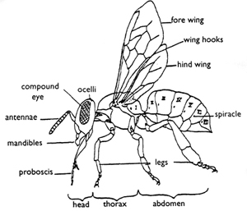

**Exercise:**

1. Give the meaning of the term apiary.
2. Why are bees grouped under social insects?
3. Give two examples of social insects.

**Activity:** By use of magnifying glass pupils will observe external parts of a bee.

**……………………………………………………………………………………………..**

**Lesson 9**

**New words:**

* **Maiden flight:** a flight from which the drone mates with the queen bee.

**Types of bees in a hive**

1. Queen bee
2. Drone bee
3. Worker bee

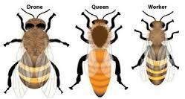

**The queen bee**

**Characteristics of queen bee**

1. It has along abdomen and long legs.
2. It is the largest bee in the hive
3. It has shorter wings as compared to its body.
4. It has the ovipositor for laying eggs.

NB**:** Its life span is 4 – 5 years. It lays between 1500 – 3000 eggs per day.

**Function of the queen bee in the hive**

* To lay eggs in the hive.

**The drone bee**

**Characteristics of a drone bee**

1. It is the male bee in the hive
2. It has a blunt hairy abdomen
3. It is the only bee without a sting in the hive.
4. It develops from unfertilized eggs laid by worker bees.

**NB.** It is almost never in the hive because it is killed after mating the queen.

**Function of a drone bee**

* To mate with the queen bee.
* It fertilizes the queens eggs.

**Wedding flight / maiden flight**

A wedding flight is a flight during which the drone bee mates the queen bee.

**Why does the drone bee die after the wedding flight?**

Due to loss of its reproductive organ (tract) during mating.

**Exercise:**

1. What is the role of a drone bee in a hive?
2. Give any two characteristics of a queen bee.
3. Why does a drone bee die after the wedding flight?

**Activity:** Observing the worker bee.

……………………………………………………………………………………………

**Lesson 10**

**New words:**

* **Sterile:** unable to reproduce.
* **Nectar:** sweet juice found in flowers

**Worker bee**

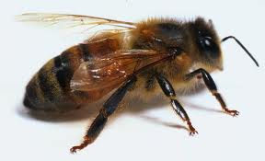

**Characteristics of the worker bees**

1. They are the smallest and busiest bees in the hive.
2. They have a sting used for defence
3. They have a pollen basket on their hind leg for carrying pollen grains.
4. They are female sterile bees because their reproduction organs are under developed.
5. When their eggs happen to hatch, they grab develops into a drone.

**Diagram showing the hind leg of a worker bee**

**Roles of the worker bees**

1. Guards the hive.
2. Collect nectar, water and pollen grains.
3. Build the hive using wax.
4. Clean the hive.
5. Collect propolis used to seal the cracks on the hive.
6. Feed the grubs (larvae) on honey.
7. Feed the queen bee on royal jelly.
8. Fan the hive to reduce(lower) the temperature
9. Make honey and store it in the honey combs.

**General habits of bees:**

1. Bees make woggle and round dances to communicate
2. Bees swarm from one place to another
3. Bees collect nectar and pollen grain from flower.

**Terms used in apiculture:**

1. **Apiculture:** Is the keeping and management of bees (refers to bee keeping)
2. **An apiary:** Is a farm of bees / a collection of bees hives or a place where bees are kept.
3. **Hiving:** Is the act of attracting bees to the hive using baits.
4. **Baits:** are things used to attract bees into the hive e.g. fruit juices, ripe bananas, cow dung e.t.c.
5. **A colony:** Is a group of bees living together.
6. **Swarming:** Is the movement of a colony of bees from one place to another for a purpose.
7. **Maiden / marital flight:** Is a flight during which the drone bee mates with the Queen bee.

**Exercise:**

1. Briefly explain the term colony as used in bee keeping.
2. Write any two roles of worker bees in a hive.
3. Briefly explain the term apiculture as used in bee keeping.

**Activity:** Observing the external parts of a worker bee.

Drawing a worker bee.

**………………………………………………………………………………………………**

**WEEK 3**

**Lesson 1**

**A SWARM**

***New words:***

* **Swarm**: is a group of bees either deserted or moving.
* **Swarming:** the movement of bees in a colony for a purpose.

Bees always store enough honey in their stomachs to last them for some days.

After swarming, the bees settle down on a branch to wait for the scouts or messenger bees that are sent to look for a new hive to come back.

**Why bees swarm**

1. Bees swarm when they are over crowded in the hive
2. When a new queen bee is born.
3. Due to a bad smell near the hive or inside the hive.
4. Due to dampness in the hive (incase the hive leaks)
5. Due to direct sunlight into the hive.
6. In case the bees are attached by enemies.
7. Due to shortage of food and water in an area due to drought.
8. In case the queen bee dies.
9. If there are two or more queen bees in the hive.

**Life cycle of a bee**

Bees undergo a complete metamorphosis i.e.

Eggs – Larva (grubs) - Pupae – Adult (Imago)

**Diagram showing the life cycle of a bee**

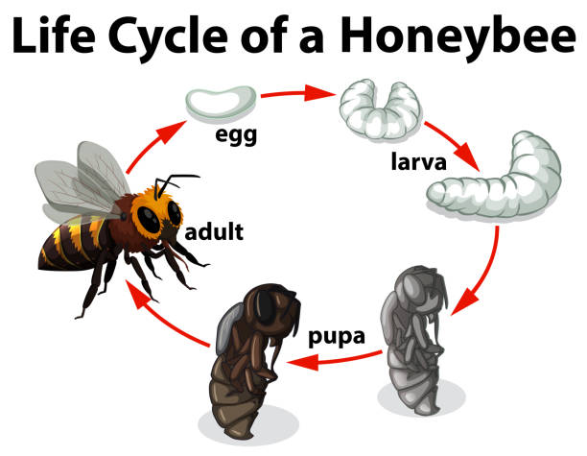

**Exercise:**

1. What is swarming in bee keeping?
2. Suggest any two reasons why bees swarm.
3. How many stages of development does a bee undergo?

**Activity:**

1. Observing the eggs and larvae of bees.

………………………………………………………………………………………………….

**Lesson 2**

**New words:**

* **Hive**: a home of bees.
* **Grub**: the larva stage of a bee.

**Bee hives**

Bees naturally hive in holes in the ground, caves or in hollows in big trees.

When a farmer wants to keep bees, he provides for them a shelter called a bee hive.

**Types of bee hives**

There are two types of bee hive.

1. Traditional (local bee hive)
2. Modern bee hive.

**Local bee hive:**

**Examples of local bee hive:**

a). Kigezi bee hive b). Dug out log bee hive

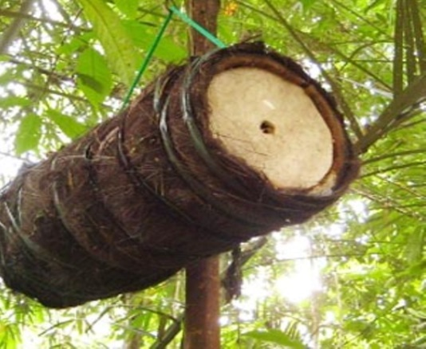

**Advantages of local bee hive**

1. They are easy to make
2. They are made from locally available materials
3. They are cheap to maintain.

**Disadvantages of local bee hive**

1. It is easily destroyed
2. Not easy to inspect
3. Lasts for time
4. Honey is not always clean
5. Not easy to harvest honey.

**Modern bee hives:**

Examples include: - Box bee hive

* Top bar bee hive

**Internal structure of a modern beehive**

[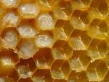](http://www.google.com/url?q=http://nothingbuthoney.wordpress.com/category/interior-structure-of-beehives/&sa=U&ei=97HnUt3TM6n40gWm7ICYCw&ved=0CDgQ9QEwBQ&usg=AFQjCNG-kAQJqrQlx0_geEB7gUjjJSzVfA)

**Section in a modern bee hive:**

**Brood chamber**: Where queen lays eggs which later hatch into grubs (larvae)

**Honey chamber**: This where the worker bees keep honey. Only workers can reach this section. The honey is clean without eggs or larvae.

**Queen excluder**: Separates the honey chamber from the brood.

Therefore the queen excluder prevents honey from getting contaminated.

**Advantages of a top bar hive:**

1. The hive can easily be inspected
2. Harvested honey is always clean
3. Top bar hive is durable (lasts for along time)
4. Only the honey combs which are ready can be harvested.

**Disadvantages of a top bar hive**

A top bar hive is expensive to make.

**EXERCISE:**

1. Name one type of bee hive.
2. Give any one importance of a queen excluder in a modern bee hive?

**ACTIVITY:**

Observing the parts of a modern bee hive.

**LESSON 3**

**STARTING A COLONY**

**NEW WORDS:**

1. **Baits:** materials
2. which attract bees into a hive.
3. **Colony:** a group of bees living together.

**Requirements for starting a colony**

1. Queen bee
2. Baits e.g. sugar solution for the bees to feed on.
3. A trough of water to place near the hive.
4. A flower garden.

**Stocking a hive:**

Stocking a hive means putting bees in an empty hive to occupy it.

**How is stocking done in apiculture?**

By setting up a hive, putting baits and waiting for the bees to occupy itor Trapping bees into the hive using a swarm catcher.

**Diagram of a swarm catcher**

[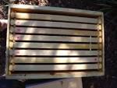](http://www.google.com/url?q=http://www.overallgardener.com/2012/03/&sa=U&ei=xbDnUs2wOaWa0AXqzYHgCQ&ved=0CDYQ9QEwBA&usg=AFQjCNFZ-dN7oHK3ASO6pr3grCtU0AfYMg)

NB: The farmer uses the above swarm catcher to transfer the bees trapped to the main hive.

**Location of an apiary (farm of bees)**

1. Away from people or animals to avoid disturbances
2. Away from the main road
3. In a sheltered and quiet (under shade)
4. Near a water source
5. Near flowering plants.

**HARVESTING HONEY**

1. Dress in suitable clothing e.g. overall
2. Make sure the smoker works properly.
3. Lower the hive to the ground to avoid damaging the combs.
4. Avoid killing the bees.
5. Leave some old combs for the bees to suck honey.

**The best time of the day for harvesting honey**

In the evening when it is cool and all the bees are settled or clam.

**Equipment for harvesting**

1. A bucket (pan) for collecting honey.
2. A knife: used to cut honey combs
3. Overall to protect the harvester from stings.
4. Bees veil: to protect the face from bee stings
5. Gloves: to protect the hands
6. Gum Boats: to protect the feet.
7. A smoker: to produce smoke that calms bees.

**EXERCISE:**

1. Identify any two equipments used in harvesting honey.
2. Give the importance of the following when harvesting hone: a bucket, a smoker and a knife.

**ACTIVITY:**

Dressing up ready to harvest honey.

**LESSON 4**

**NEW WORDS:**

1. **Combs:** hexagonal shaped structures where bees store honey.
2. **Brood:** a group of young bees.

**THE HONEY HARVESTER**

**Bee products (summary)**

1. **Honey**
2. **Bee wax**
3. **Propolis**

**Which food value do you mostly got from eating honey?**

We mostly get carbohydrates.

**Methods of harvesting honey:**

1. Traditional methods. Smoke is used to calm bees and honey is extracted from the combs.
2. Modern methods where machines are used to extract honey.

**Methods of extracting honey:**

1. Centrifuging method
2. Floating wax method
3. Pressing honey method

**Importance of honey to man**

1. Honey is eaten directly as food
2. Honey is used to sweeten tea.
3. Liquid honey is eaten with bread and cakes.
4. Honey is used to make alcoholic drinks.
5. Honey is used to treat cough.
6. Honey can be sold to get money.

**Industrial uses of honey**

1. Honey is used to make medicine e.g. cough syrups.
2. It is also used to make sweets, chocolate.
3. It is used in fruit canning as a preservative.
4. Honey is used to make cosmetics e.g lip shiner.
5. Honey is also used in hospitals to dress wounds in surgical cases.

**Exercise:**

1. How is a smoker useful during honey harvesting?
2. Give any two products got from bee wax.
3. Identify any one method of extracting honey.

**Activity:**

Observing harvesting of honey on a projector.

**LESSON 5**

**New words:**

1. **Cosmetics**
2. **Varnish**

**Bee farming as business:**

1. One can rear queen bees which can be sold for money.
2. One can rear bees which provide honey on a large scale for sale.
3. Bee wax can be extracted on a large scale for sale in order to make other products.

**Importance of bee wax to man**

1. For making shoe polish
2. For making crayons used in painting
3. For making candle wax
4. To make varnish for furniture
5. To make cosmetics like body creams / Vaseline.

**Advantages of keeping bees**

1. Apiculture takes little space i.e. the land under the lives can be used for crop farming.
2. Less labour and attention is needed since bees look for their own food.
3. Bee farmers get regular income from bee products like honey.
4. Bees pollinate flowers.

**BEE ENEMIES**

**Examples of bee pests include**

1. Wood ants
2. Safari ants
3. Rats
4. Wasps
5. Wax moth
6. Honey badger.

**Diseases of bees**

Bees are resistant to diseases but the following diseases can attack them:-

1. American foul brood
2. Stone brood
3. Bald brood
4. European foul brood
5. Nosema

**How can we prevent enemies from destroying bees?**

1. By oiling the base of the poles on which bees are.
2. Putting grease on the wives to prevent the ants from climbing.
3. Spraying insecticides at the base of poles to kill the pests.
4. Keeping the grass around the hives short.
5. Hanging the hives in trees 100 – 150cm high.

**EXERCISE:**

1. Give any two enemies of bees.
2. Why do farmers rear bees?

**ACTIVITY:**

Observing extraction of honey and bee wax from honey combs on a projector.

**LESSON 6**

**THEME: MATTER AND ENERGY**

**NEW WORDS:**

1. **Matter:** anything which occupies space and has weight.
2. **Energy:** the ability of the body to do work.

**TOPIC: MEASUREMENT**

It is the process of finding out how long, short, big, small, heavy or light an object is.

**Mass**

1. It is the amount or quantity of matter in an object.
2. It is measured in grams (g), kg (kilograms).

NB: Its standard unit is kg.

**Gravity:** Is the force of the earth that pulls down objects. or Is the force of attraction that objects have on one another because of their masses.

NB On earth the gravitational force acting on mass is 10N

The size of the force becomes smaller as the object moves further from the surface of the earth.

**Length**

1. It is the distance between two point
2. It is measured in metres (m), centimeters (cm) Hecto metres (hm), millimetres (mm, decametre (Dm) decimeters (dm).

NB: The standard units for length are **Metres**

**Instruments used to measure length**

1. Tape measures
2. Metre rulers
3. Foot rulers
4. Sticks
5. Strings
6. Strides

**A line segment:** Is a line between two points.

**EXERCISE:**

Draw line segments of different length.

a). 4cm b) 6cm c) 8cm d) 14cm

**ACTIVITY:**

1. Measuring objects using rulers and strings.
2. Drawing lines and measuring them.

**LESSON 7**

**NEW WORDS:**

1. **Area:** It is the total space covered by an object.

It is measured in Square Units cm2, m2, dm2, km2.

**Area of a rectangle**

Width (w)

Length (L)

The width is the shorter side of a rectangle

The length is the longer side of a rectangle

Area = Length x Width = sq units

6 squares

By counting the squares

24 squares

Area = L x W

= 6 squares x 4 squares

= 24 squares

4 squares

NB: A regular rectangle has two opposite sides equal.

**Area of a square**

A square has all its sides equal

Area = s x s

Area = s x s

= 4cm x 4cm

= 16cm2

S2

4cm

**EXERCISE:**

**Find the area of the following:**

1. Rectangle of length 5cm and width of 3cm .
2. Square of side 6cm.

**ACTIVITY:**

1. Drawing rectangles and squares.
2. Measuring lengths of rectangular shapes.

**LESSON 8**

**NEW WORDS:**

1. **Volume:** It is the space occupied by an object

It is measured in cubic units (cc, cm2, mm3, m3)

**Regular objects**

They are objects with specific (definite) shapes e.g. cuboids, bricks, blocks, tins, rectangles, square etc

**Finding volume of regular objects**

V = L x W x H = Cubic units

Height (H)

Width (W)

Length (L)

Find the volume of the figure above.

**CAPACITY:**

1. Capacity is the amount of liquid in a given container.
2. It is measured in litters, milliliters.
3. Standard units for measuring capacity are litters.
4. Capacity is measured using measuring cylinders, cups, jerry cans, tanks etc.

**EXERCISE:**

**Find the volume of the shape below.**

**5cm**

**4cm**

**6cm**

**ACTIVITY:**

1. Drawing solid shapes.
2. Pouring water in solid shapes eg cylindrical objects.

**LESSON 9 & 10**

**NEW WORDS:**

1. **Irregular objects:** objects that do not have a specific shape e.g. stones.
2. **Regular objects:** objects with specific shape.

**Displacement method**

Is the method used to find the volume of irregular objects?

**Instruments used to measure the volume of irregular objects**

1. Measuring cylinder
2. An over flow can or Eureka can

Why do we use the displacement method to find the volume of stone?

It has no specific shape

**Using a measuring cylinder to find volume of an irregular object.**

**Procedure**

**Step I**

Pour water into a measuring cylinder about half full and record the volume of the water.

**Step II**

Gently lower the irregular object tied on a string into the measuring cylinder.

**Step III**

Record the final level of the water in the measuring cylinder.

**Step IV**

Subtract the first level from the final level.

V = Final level – 1st level

V = 40cc – 30cc

V = 10cc

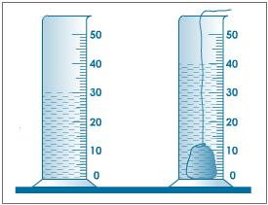

**NB**

The volume of the irregular object is equal to the volume of the displaced water.

**Using an over flow can (Eureka can)**

**Step I**

Pour water in the can up to the level of the spout

**Step II**

Put the irregular object tied on a thread gently in the can.

**Step III**

Collect the water that pours out of the can in a measuring cylinder

1. What is the volume of the stone?

**30cc**

1. What is the use of the string (thread) in the experiment above? To gently lower the stone into the water and avoid it from splashing.

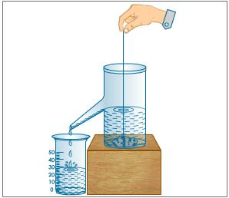

**EXERCISE:**

1. What is the use of a measuring cylinder in the displacement method?
2. How is a string useful when finding the volume of irregular objects?
3. Why is displacement method used for finding the volume of irregular objects?

**ACTIVITY:**

* Carrying out experiments using displacement method.

**WEEK 4**

**LESSON 1**

**NEW WORDS:**

1. **Mass:** the amount of matter in an object.
2. **Gravity:** the force that pulls objects towards the ground.

**Weight**

It is the gravitational force exerted on an object by the earth.

The standard unit of weight is Newton

**Mass**

1. It is the amount of matter in an object.
2. It is the quantity of matter contained in a body.

**Machines used to measure weight and mass**

Beam balance

Spring balance-weight

Set of scale

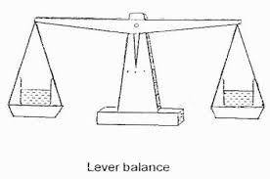

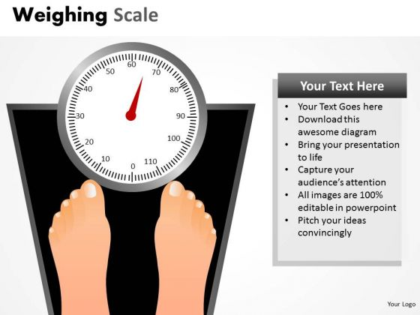

**Difference between weight and mass**

1. Mass does not change from place to place while weight changes.
2. Mass is the amount of matter in an object while weight is the force of gravity exerted on an object.
3. Mass is measured in kilograms while weight is measured in Newton (N).

**Exercise:**

1. What is weight?
2. Name the basic units used for measuring weight and mass respectively.
3. Give the difference between mass and weight.

**ACTIVITY:**

Weighing objects on a weighing balance, spring balance, etc.

**Lesson 2**

**New words:**

**Hydrometer**

**Density**

**Density**

It is the ratio of mass to volume of a substance or density of a substance is defined as its mass per unit volume.

The density of water is 1.0g/cc and ice is 0.92g/cc.

We use density bottle to measure densities of substance.

It is measured in units like (kg / cc, gm /cm3, kg/m).

Find the density of an object with mass 400gm and volumes 20cc>

D = Mass (M)

Volume D

D = Mass

Volume

D = 400gm

20

D = **20gm/cc**

**Finding mass when given density and volume:**

MASS = Density * Volume

**Finding volume when given mass and density:**

VOLUME = Mass / Density

**Exercise:**

1. Find the density of an object whose mass is 10g and volume is 5cc.
2. What is the mass of an object whose density is 2g/cc and volume is 3cc.

**Activity:**

Weighing objects.

**LESSON 3**

**NEW WORDS:**

1. **Floating:** remaining on top water when thrown on water.
2. **Sinking:** going to the bottom of water when dropped in water.

**Floating objects**

1. Floating is when an object stays on top when thrown on water.
2. Objects float because they are less dense than water.
3. When an object floats in a fluid, two forces act on it; its own weight and up thrust force of the fluid.

**Examples of floating objects**

1. Cork
2. Plastic
3. Boats
4. Sponge
5. Feather
6. Leaves
7. Soft dry wood
8. Paper
9. Petrol, paraffin

**Sinking**

1. It is when an object thrown on water goes to the bottom of the water.
2. Objects sink because they are denser than water.

**Buoyancy or upthrust:**

1. Buoyancy is an upward force of a liquid acting on an object.
2. All objects weigh less when in a liquid than in air because liquids have greater upthrust than air.
3. All liquids press upwards on objects dropped in them.

**Examples of sinking objects**

1. Stones
2. Sand
3. Soil
4. Metal
5. Glass
6. Nails
7. Coins
8. Pins
9. Clay

NB: Any sinking objects displace water equal to its volume.

**EXERCISE:**

1. Use the experiment below to answer the questions below.

[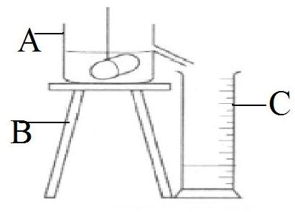](http://www.proprofs.com/quiz-school/user_upload/ckeditor/eureka%20can%20label(2).jpg)

* 1. What is the volume of the stone?

……………………………………………………………………………

* 1. Name the objects marked

……………………………………………………………………………

* 1. Why is the above method used to find the volume of the stone?
  2. Why do we use displacement method to find the volume of irregular object?

……………………………………………………………………………

**ACTIVITY:**

1. Collecting different objects from the compound.
2. Dropping objects in water

**LESSON 4**

**NEW WORDS:**

1. **Immunization**: is the administration/ introduction of vaccines into the body to cause immunity.

Is a way of putting vaccines into the body in order to cause immunity.

1. **Immunity**: is the body’s ability to resist disease germs.

**THEME: HUMAN HEALTH**

**TOPIC: IMMUNISATION**

**IMMUNITY**

**TYPES OF IMMUNITY**

There are two types of immunity.

1. Natural immunity.
2. Acquired.

**Natural Immunity**

Is the type of immunity a baby or a person gets without using vaccines.

**Ways of getting natural immunity:**

1. Suffering and recovering from a disease.
2. Through breast feeding.
3. From a mother to child while in the womb.
4. Through eating a balance diet.

**Acquired Immunity**

1. Is the type of immunity a person gets through receiving vaccines in the body.
2. Acquired immunity can be got through immunization.

**VACCINES**

Vaccines are medical substances which are introduced into the body to produce antibodies against certain diseases.

Vaccines take the form of dead or weakened bacteria or viruses that can still act as antigens.

Vaccines can be administered orally or through an injection.

**ANTIBODIES**

These are chemical substances produced by white blood cells to defend the body against diseases.

**TYPES OF VACCINES**

There are three types of vaccines

1. Toxoids
2. Attenuated vaccines
3. Killed vaccines

**Toxoids**

There are prepared from toxins produced by bacteria in the body. They are made harmless and injected into the body like T.T vaccines.

**Killed / Dead vaccines**

These are killed bacteria or virus that has been grown in suitable host cells. They are made harmless before being injected into a person e.g. cholera and the sack anti polio vaccine.

**Attenuated vaccines**

These are live bacteria or virus which has been weakened in such a way that they can not cause diseases. When injected into the body, they cause immunity.

**Importance of immunity to our body**

1. Protects us from being attacked by diseases.
2. Boosts our body immune system.

**How does baby get immunity?**

1. From mother to child during development in the womb.
2. Through immunization from vaccination.
3. After suffering and recovering from an illness.

**Write in full:**

1. DPT: Diphtheria pertussis Tetanus
2. OPV: Oral Polio Vaccine
3. IPV : Injectable Polio Vaccine
4. TT : Tetanus Toxoid

**EXERCISE:**

1. Briefly explain the term immunization.
2. Give the types of immunity.
3. Write two ways babies get immunity.

**ACTIVITY:**

1. Identifying immunization sites.
2. Role play about immunization.

**LESSON 5 & 6**

**NEW WORDS:**

1. **Infant: a child below six years of age.**
2. **Sputum: mucus like liquid from the lungs.**

**CHILDHOOD IMMUNIZATION DISEASES**

The six childhood killer diseases attack children below the age of six years.

These are:

1. Poliomyelitis (Polio)
2. Measles
3. Tuberculosis
4. Diphtheria
5. Whooping cough (pertussis)
6. Tetanus

**Other Immunisable diseases**

1. Cholera
2. Yellow fever
3. Meningitis
4. Rabies
5. Typhoid
6. Hepatitis B
7. Haemophilus Infuenza b
8. Plague
9. Rubella (Geman, measles)
10. Typhus fever

**DISEASES, CAUSE, SIGNS, SYMPTOMS, PREVENTION AND TREATMENT**

|  |  |  |  |  |  |  |
| --- | --- | --- | --- | --- | --- | --- |
| disease | cause | spread | signs | symptoms | prevention | treatment |
| tuberculosis | bacteria | Through air | -A lot of sweating  -Loss of weight  Chronic cough | -Mild fever  -Loss of appetite  -body weakness  -chest pain | immunization | Use of antibiotics |
| measles | virus | Body contact  Throat secretions | Sore in the mouth  Runny nose  Skin rash  Dry cough  Red eyes | fever  Itching skins  Body weakness | Isolation of infected persons.  Immunize | There is no proper treatment. |
| Whooping cough(pertusis) | bacteria | through droplet infection | Running nose  Watery discharge from eyes, sneezing.  Quick deep breath  Mild cough. | Fever  A cold | Isolation of infected persons.  Immunize | Use of antibiotics |
| diphtheria | bacteria | through droplet infection | Swollen neck  Sore throat | Pain in the neck  Itching in the neck | Isolation of infected persons.  Immunize | Use of antibiotics |
| tetanus | bacteria | Through open wounds and cuts | Stiff muscles  Difficulty in swallowing  Baby stops suckling | fever | immunisation |  |
| polio | virus | Through contaminated water and food | Paralysis in the limbs | Weakness of joints  High fever | Drinking boiled water  Proper disposal of faeces  Immunize with polio vaccine |  |
| Hepatitis B | Vurus  Which affects the liver | Contact with blood of an infected person | Very dark urine  Very pale stool  No treatment | Body weakness  Stomach upset | immunisation |  |

**LESSON 7**

**New words;**

Vaccine

Orally

injection

**IMMUNIZATION SITES**

|  |  |  |  |  |
| --- | --- | --- | --- | --- |
|  | **AGE** | **VACCINE** | **DISEASE** | **METHOD AND SITE** |
| a | At birth | BCG & Polio vaccine | Tuberculosis  polio | Injection-right upper arm  Drops in the mouth |
| b | 6 weeks | DPT vaccine  Polio vaccine | Diphtheria Pertussis Tetanus Poliomyelitis | Injection on the left upper thigh  Drops in the mouth |
| c | 10 weeks | DPT vaccine polio | Diphtheria Pertussis Tetanus Poliomyelitis | Injection on the left upper thigh  Drops in the mouth |
| d | 14 weeks | DPT vaccine & Polio vaccine | Diphtheria Pertussis Tetanus Poliomyelitis | Injection on the left upper thigh  Drops in the mouth |
| e | 9 months 36 weeks | Measles vaccine | Measles | Injection on the left upper arm. |

**EXERCISE:**

1. How is polio vaccine administered?
2. At what site is polio vaccine administered?
3. Name the vaccines administered on the left upper thigh.

**ACTIVITY:**

1. Identifying immunization sites.
2. Role play about immunization.

**LESSON 8**

**NEW WORDS:**

1. **Child health card:** a written document given by a health worker to any child who has been immunized.

**IMMUNIZATION CARD (C H C) CHILD HEALTH CARD**

This is a card given by health workers at a health centre to every child (baby) who receives immunization

**A child health card shows the following information about a baby**

1. Date of birth (D.O.B)
2. Date of next visit for immunization
3. Vaccine received and date
4. Birth weight of the child
5. Child’s name
6. Parent’s name, place of residence, parent’s occupation.
7. Birth order
8. Doctor’s advice to health growth and nutrition of the child.

**Importance of a child health card**

1. Helps to remind the parent of the next date of visit for immunization
2. Helps the parent to monitor the child growth
3. Helps both the doctor and the parent to know which vaccine was already given and which one is remaining.

**EXERCISE:**

1. Briefly explain a child health card.
2. How is a child health card important to a mother?
3. Identify any two components of a child health card.

**ACTIVITY:**

1. Reading the components of a child health card.

**LESSON 9**

**NEW WORDS:**

1. **Family:** a group of people united by blood or marriage.
2. **Community:** a group of people living and working together.

**Roles of individual, families and communities in immunization**

**Individuals**

1. Helps to inform other family members and neighbors on immunization dates and venue.
2. Learning how to immunize so that they can help the health workers.
3. Help to accept and convince other people to accept immunization as an important program.
4. Encourage others to take their children for immunization.
5. Assisting health workers in arranging the places selected for immunization

**Family**

1. Share all information that they know about immunization.
2. Parents should make sure that all children and pregnant women are immunized.
3. Bigger children should take younger ones for immunization
4. **Community**
5. Organize seminars, workshops, plays and concerts to educate others about immunization
6. Schools should perform plays and concerts about immunization on open days and speech days.

**NOTE:** The common immunization centers in our communities include; hospital, clinics, dispensaries, health centers etc.

**EXERCISE:**

1. What is the role of parents in immunization?
2. How is a community important in the immunization programs?
3. Name any one immunization centre in our community.

**ACTIVITY:**

1. Role play about immunization.

**LESSON 10**

**THEME HUMAN BODY**

**TOPIC: THE DIGESTIVE SYSTEM**

**NEW WORDS:**

1. **Digestion:** – Is a process by which food is broken into simple forms that can be absorbed in the blood stream.
2. **The alimentary canal (digestive gut):** Is the tube in the body of animals in which food moves by peristalsis. Is the muscular tube that runs from the mouth to the anus.

**Types of digestion:**

1. Mechanical digestion done by the teeth in the mouth.
2. Chemical digestion done by the enzymes.

**THE DIGESTIVE SYSTEM**

Is a group of parts which work together to digest food in the body.

**Parts of the alimentary canal**

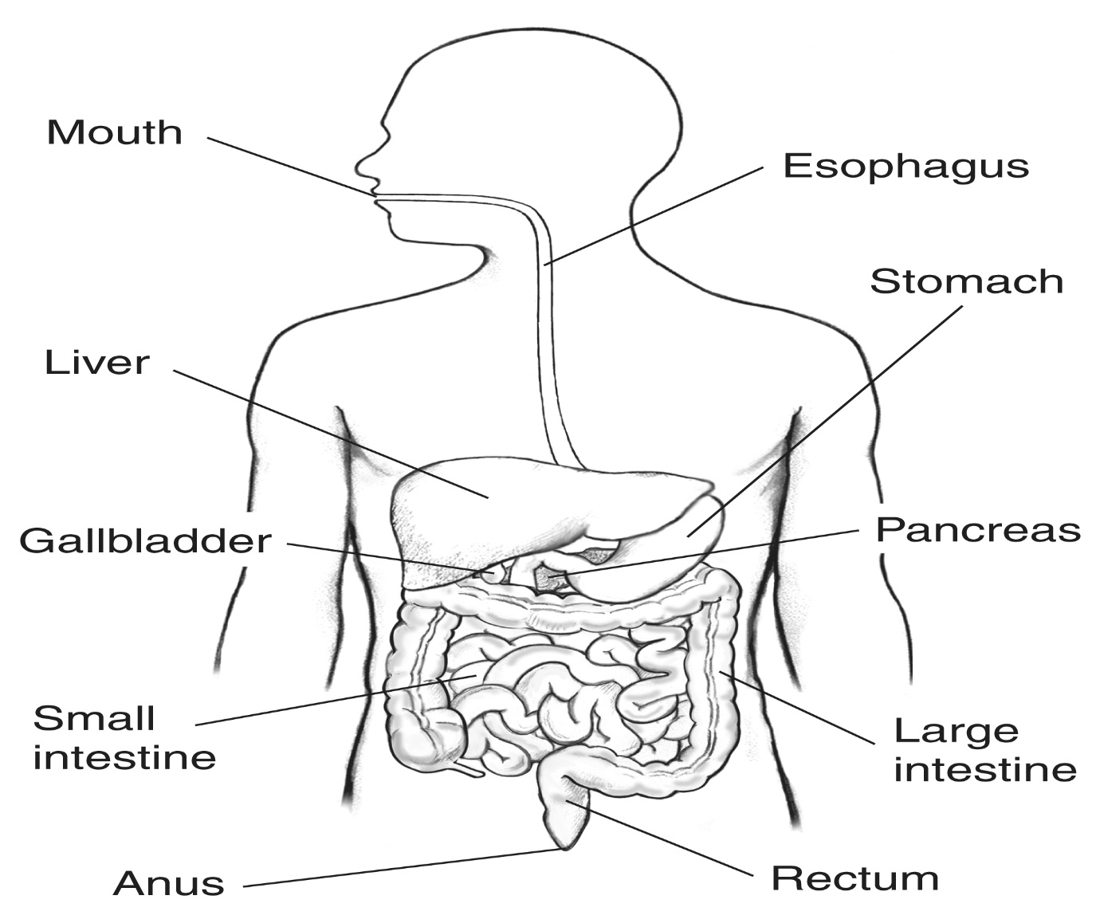

**Organs of the digestive system:**

1. Stomach
2. Liver
3. Pancreas
4. Intestine

**EXERCISE:**

1. Briefly explain the term digestion.
2. Name one part of the alimentary canal.

**ACTIVITY:**

Watching pictures about the digestive system on a projector.

**WEEK FIVE**

**MID TERM ONE EXAMINATION**

**WEEK 6**

**LESSON 1**

**NEW WORDS:**

1. **Oesophagus :** a tube which leads food from the mouth to the stomach.
2. **Peristalsis:** the process by which food bolus moves through the gullet.

**Uses of the parts of the digestive system**

**Mouth**

1. It is where digestion begins.
2. Food is broken into simpler forms by the teeth.
3. Food is mixed with saliva to make it soft for easy swallowing.

**Saliva**

1. It is a digestive juice produced by the salivary glands in the mouth
2. It has an enzyme called salivary amylase or ptyalin.
3. Ptyalin breaks down starch into maltose.
4. It also has mucus which lubricates the food.

**The** **tongue**

1. It rolls food into bolus
2. It is used for tasting.
3. It pushes the food into the gullet

**Gullet (oesophagus)**

It leads food from the mouth to the stomach.

Food passes through the gullet by the process of peristalsis.

**Illustration of peristalsis.**

[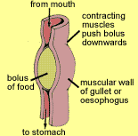](http://www.abpischools.org.uk/res/coResourceImport/resources04/digestion/images/5d4oesoph.gif)

**Epiglottis**

It prevents food from entering the wind pipe.

**Stomach**

1. It keeps food for 1-4hrs depending on the type of food.
2. The stomach walls produce the gastric juice and hydrochloric acid

**Diagram showing the stomach**

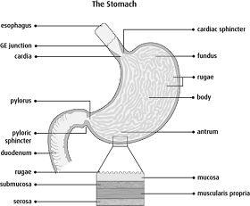

**Hydrochloric acid –** kills most of the germs brought by the food into the stomach.

1. The gastric juice contains an enzyme called pepsin which starts the digestion of proteins.
2. Alcohol is absorbed in the stomach. Drugs are also absorbed in the stomach.
3. Provides suitable conditions for pepsin to work.

**The duodenum**

1. It is the first section of the small intestine. Food is mixed with bile and pancreatic juice.
2. It receives bile juice and pancreatic juice through the bile and the pancreatic duct respectively.
3. The pancreatic juice contains an enzyme called trypsin which breaks down proteins.

**Diagram showing the duodenum.**

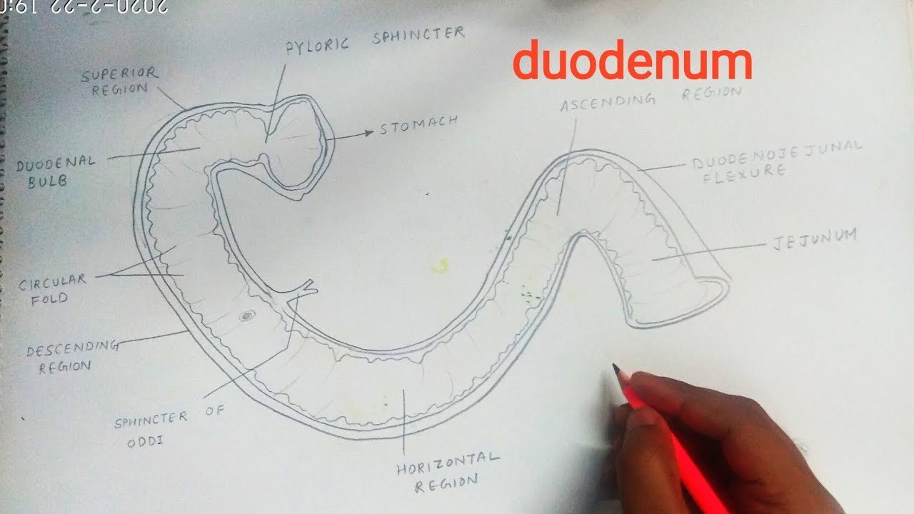

**EXERCISE:**

1. Where does digestion of food starts from in humans?
2. How is saliva useful during digestion?
3. Give one role of the stomach in digestion.

**ACTIVITY:**

1. Watching the pictures of the digestive system on a projector.

**LESSON 2**

**NEW WORDS:**

1. **Ingestion:** the act of taking food into the mouth.
2. **Egestion:** the process by which undigested food particles arereleased out through the anus as faeces.

**The liver**

It produces the bile juice

**Gall bladder**

1. It keeps or stores the bile juice.
2. Bile has salts that breaks (emulsify) fats for easy digestion.

**The pancreas**

1. It produces the pancreatic juice.
2. The pancreatic juice has enzymes that complete the digestion of carbohydrates, proteins and fats.

**The Small intestine**

1. It is the second part of the small intestine
2. It is where the digestion of food ends.
3. It is where the absorption of food takes place.

**Enzymes which act on food:**

|  |  |  |
| --- | --- | --- |
| **Food** | **enzyme** | **site** |
| Carbohydrates | Salivary amylase | In the mouth |
|  | Pancreatic amylase | In the duodenum |
| Proteins | Renine for milk proteins  Pepsin | In the stomach |
|  | trypsin | In the duodenum |
| Fats | lipase | In the duodenum |

**The end products of digestion:**

|  |  |
| --- | --- |
| Food | End product. |
| Proteins | Amino acids |
| Carbohydrates | glucose |
| Fats | Fatty acids and glycerol |

**Absorption**

1. Is a process by which digested food is taken into the blood stream.
2. The ileum has finger like projection called the villi
3. The villi absorbs food
4. The walls of the ileum produce a juice called intestinal juice that completes the digestion of food.

**How the small intestines is adapted to its function**

1. It has a large surface area made of villi and micro villi
2. It has a lot of blood capillaries which allow the transportation of blood molecules all over the body.
3. It is long enough to increase the surface area for food absorption.

**The large intestine (colon)**

It is where water and mineral salts are absorbed.

**Rectum**

It keeps the undigested waste materials before they are passed out

**Anus**

1. It passes out the undigested materials
2. It is used for egestion.

**Components of faeces**

1. Water
2. Dead cells
3. roughage
4. Bacteria

**EXERCISE:**

1. Where does digestion end in the human body?
2. Briefly explain the term absorption of food.
3. How are the small intestines adapted to their function?

**ACTIVITY:**

1. Observing the movement of digested and undigested food particles through the gut on a projector.

**LESSON 3**

**NEW WORDS**

1. **Disorder:** a problem which prevents the body system from functioning well.

**Disorder and disease of the digestive system**

**Disorder**

They are problems that can make the alimentary canal fail function well.

**Constipation**

It is when the undigested matter stays in the rectum for too long.

**Causes**

1. Lock of roughage in the diet
2. Drinking little water
3. Lack of physical exercise

**How to prevent constipation**

1. Eat fruits and vegetables e.g. mangoes, apples e.t.c.
2. Doing plenty of physical exercises.
3. Drinking water before and after eating food.
4. Eating a balanced diet.

**Indigestion**

It occurs when the food we eat is not properly digested

**Causes of indigestion**

1. Improper chewing of food
2. Over eating

**Symptoms of indigestion**

1. Stomach ache
2. Heart burns
3. Tiredness/ fatigue

**Prevention of indigestion**

1. Chewing food properly before swallowing.
2. Drinking enough water before and after eating food.
3. Avoid eating hurriedly.
4. Seek medical advice.

**Vomiting**

1. It is a disorder caused by eating poisonous food or over eating
2. It can also be caused due to some diseases e.g. malaria

**EXERCISE:**

1. Name one disorder of the digestive system.
2. Write one way of preventing constipation.
3. Identify one symptom of indigestion.

**ACTIVITY:**

1. Chewing food.
2. Drinking water.

**LESSON 4**

**NEW WORDS**

**Contamination:** this is when something goes bad or dirty.

**Diseases of the digestive system**

**Appendicitis**

1. It is caused by bacteria that enters the appendix
2. It leads to swelling of the appendix
3. It causes too much pain in the lower right side of the abdomen.
4. It can be treated by cutting it off.

**cholera**

1. Cholera is used by bacteria
2. It is spread by houseflies, cockroaches.
3. It is also spread by drinking contaminated water and eating contaminated food.

**Symptoms of cholera**

Pain around the abdomen

**Control of cholera**

1. Boil water before drinking it.
2. Kill houseflies by spraying
3. Wash hands before eating, serving or handling food.
4. Wash hands after visiting the toilet or latrine
5. Cover cooked food to keep away houseflies.
6. Properly dispose human faeces

**Typhoid**

1. It is caused by bacteria
2. It can be spread by house flies
3. Typhoid can be spread by drinking contaminated water and eating dirty food

**Signs of typhoid**

Diarrhea

**Symptoms of typhoid**

1. Headache
2. Fever

**Prevention of typhoid**

1. Boiling water for drinking
2. Spraying insecticides to kill houseflies
3. Washing hands before eating food
4. Wash hands after visiting the latrine or toilet
5. Properly disposing rubbish and faeces.

**EXERCISE:**

1. Mention any one disease of the digestive system.
2. How is cholera spread?
3. Give any one a ways of controlling the spread of typhoid.

**ACTIVITY:**

1. Preparing ORS locally.

**LESSON 5**

**NEW WORDS**

1. **Dehydration:** a condition when the body does not have enough water.
2. **Anaemia:** a condition when the body does not have enough blood.

**Dysentery**

1. The frequent passing out of watery stool with blood stains.
2. Amoebic dysentery is caused by amoeba.
3. Bacillary dysentery is caused by a bacteria

**Spread of dysentery**

1. Drinking contaminated water
2. Eating contaminated food
3. Houseflies carry germs onto the food and hands.

**Control of dysentery**

1. Boiling water for drinking
2. Washing fruits before eating them
3. Spraying insecticides to kill houseflies
4. Washing hands before eating, serving food
5. Wash hands after visiting the toilets

**Dangers of dysentery**

1. It leads to dehydration
2. It leads to anaemia

**Peptic ulcers (stomach ulcers)**

1. They are wounds formed in the stomach or small intestine
2. They cause a lot of pain especially when one is hungry.

**CARE FOR THE ALIMENTARY CANAL**

1. Wash hands before eating
2. Chew food properly before swallowing it
3. Wash hands after visiting a toilet or latrine
4. Eat well looked food
5. Avoid eating very hot or cold food
6. Having regular physical exercise
7. Having enough rest after eating
8. Brushing the teeth after eating food

**EXERCISE:**

1. Give any one effect of dysentery to the body.
2. How does dysentery spread from infected people to healthy people?
3. Write one way of controlling the spread of dysentery.

**ACTIVITY:**

1. Washing hands after visiting the toilets.
2. Rinsing the mouth after eating food.
3. Preparing ORS locally.

**THE END**